**Intro to Programming (Python)**

**Assignment 07 Knowledge Document**

**I. Overview**

A. The “try/except” part of this assignment seemed pretty straight forward. I immediately thought of the previous arithmetic script where I tested the divisor for zero. For this assignment, instead of testing for zero I used try/except where I wrote the except clause as “***except ZeroDivisionError:”***  The result was as follows:

#

# Flag zero divide exception

try:

print("\nN1/N2 = ",N1/N2)

except ZeroDivisionError:

print("\nN1/N2 is indeterminate since N2 = 0")

B. The Pickling part of this assignment was more challenging. I wanted to make the resulting script more interesting than simply save and restore. So, I decided to create a list of dictionaries, where the key for each dictionary was a 4 character aircraft type code and the value was a list containing the wing span and the max landing weight of the aircraft. This data structure could easily be set up to include dozens of aircraft, but I chose to use only 4 types. The data structure which I “pickled” and them retrieved as needed was:

#

# define Aircraft Specs: type, span(m), MLW(kg/1000)

AC_Specs = [{'B747':['68.5','312.1']}, \

{'B767':['47.6','136.1']}, \

{'B777':['60.9','208.7']}, \

{'B787':['60','172.4']}]

I used a while loop to give the script user an opportunity to retrieve the specs of an aircraft of interest.

Note - The look/feel and user interaction for both scripts were initially far from what I was happy with. Numerous trial and error iterations were required before I was satisfied with the way the scripts behaved.

**II. Examples**

**A. Command line view of the try/except script:**

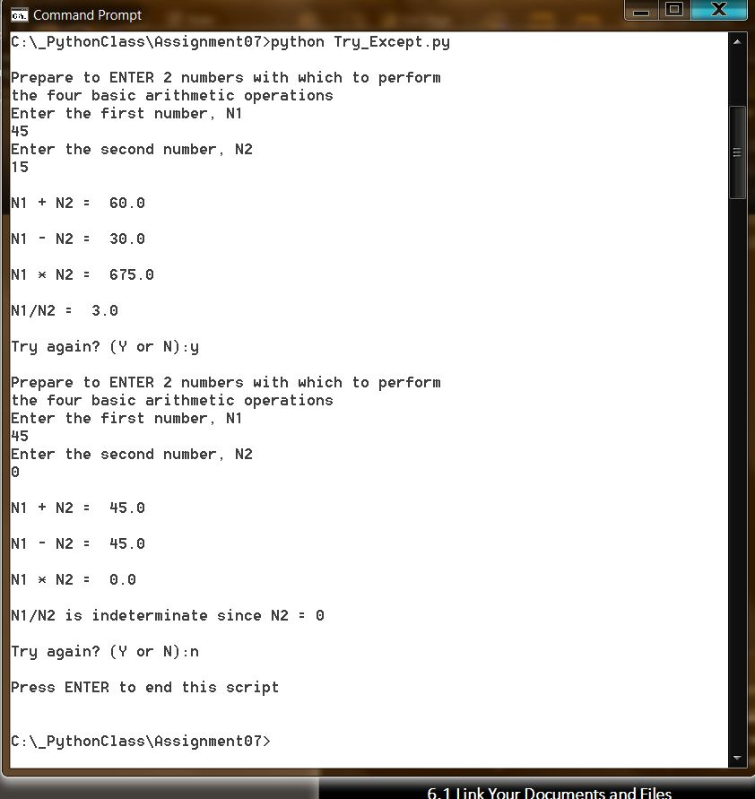

**B. Command line view of the “pickle” script:**

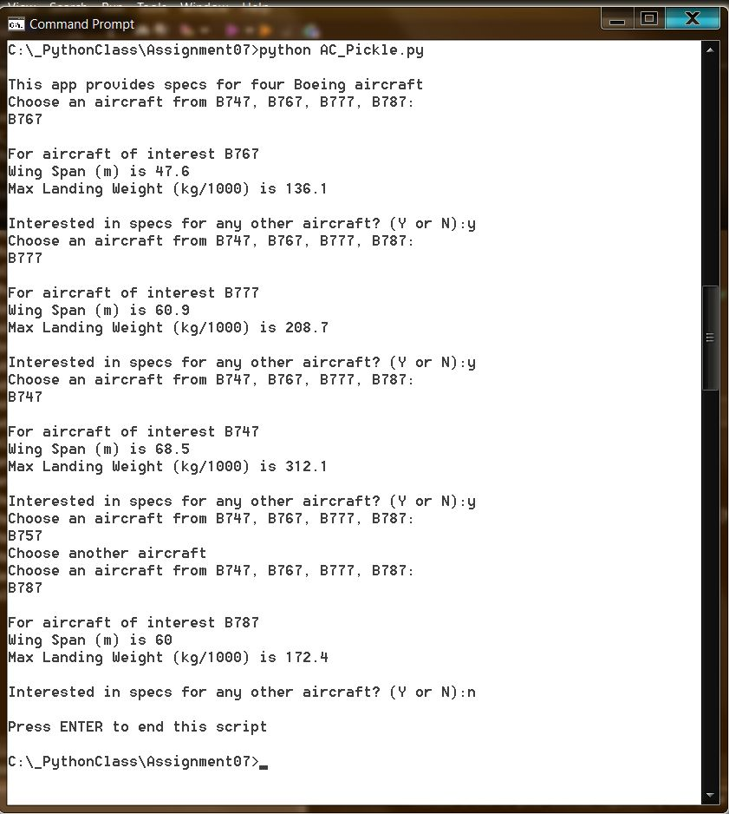

**III. Access to the completed script for Assignment #7**

As specified as part of the assignment, the code for each script was uploaded to GitHub. The scripts may be found in <https://github.com/lastduxson>. They are called Try_Except and AC_Pickle and are stored in a repository called “Early-Python-Code”.

This knowledge document can be found at the blog: **rerlearningpython.blogspot.com.**